Academic Monitoring System
Documentation
Prepared By: Miss. Karande Rupali.

VishuMangal Technologies Pvt. Ltd, Pune.

Table of Contents
Table of Contents ii
Revision History ii
1. Introduction 1
1.1 Purpose 1
1.2 Document Conventions 1
1.3 Intended Audience and Reading Suggestions 1
1.4 Project Scope 1
1.5 References 2
2. Overall Description 2
2.1 Product Perspective 2
2.2 Product Features 3
2.3 User Classes and Characteristics 4
2.4 Operating Environment 6
2.5 Design and Implementation Constraints 7
2.6 User Documentation 8
3. System Features 8
3.1 System Feature 8
4. External Interface Requirements 9
4.1 User Interfaces 9
4.2 Hardware Interfaces 9
4.3 Software Interfaces 9
4.4 Communications Interfaces 9
5. Other Nonfunctional Requirements 10
5.1 Performance Requirements 10
5.2 Safety & Security Requirements Error! Bookmark not defined.
5.3 Software Quality Attributes 11

Appendix A: Glossary 12

Revision History
Name | Date | Reason For Changes | Version

Introduction

Purpose
Academic Monitoring System provides an interface for monitoring of Institute information such as Offered courses, library, Infrastructure, resources, faculty information for respective institute and departments. It tracks all the details of an institute which can be used for all reporting purpose, progress in the course and all these will be available through a secure online interface embedded in the “Online Institute Monitoring Portal of MSBTE”. The primary objectives were to design a system is first and foremost easy to use, accurate, reliable, and secured and user friendly. Second allowed for the Institutes of individual achievement and provide more facilities to students.

Document Conventions
This document uses the following conventions.
DB: Database
CDB: Central Database
ER: Entity Relationship
Web server (WS): The container of content comprising of two layers overlay, which is a collection of Web service host (e.g. Apache, MySql) Service Level Agreement (SLA) allocator and policy agent and core, which refers to the underlying hardware infrastructure.
Mediator: A policy-driven entity, authoritative for policy negotiation and management.
Service registry (SR): Discovers and stores resource and policy information in local domain.
Policy repository (PR): A storage of Web server and mediator.
PWS: A set of Web server-specific rules for content storage and management.

Intended Audience and Reading Suggestions
This project is a prototype to optimize the monitoring and reporting of Institutes. That should improve efficiency of Institute monitoring. It can be used by only Institutes which are under the MSBTE board to improve the quality of education as well as provides more facilities to students. Achieving this objective is difficult using a manual system as the information is scattered, can be redundant and collecting relevant information may be very time consuming. In the next section, system features with their functional requirements are presented to highlight the major services provided by the intended product. Then the external interface requirements highlighting the logical characteristics of each interface between the software product and the users are discussed. Finally, this specification is concluded with the reference documents on which this document is based on.

Project Scope
The purpose of the Academic Monitoring system is easy-to-use application only for Institutes under the MSBTE board. The system is based on a relational database with its institutes audit reports. We will have a database server supporting number of Private, Unaided, Aided, Government, Autonomous and Govt-autonomous Institutes under the MSBTE.

References
This document builds on the following references:
http://118.139.176.197/~ss/msbteacmon/acmon_13/acmon_s_18_19/index.php
http://www.php.net/
php, Ajax, js, MySQL

Overall Description

Product Perspective
Academic Monitoring database system stores the following information.
Institutes details:
It includes the Institutes code, Institutes Name, Address with pin-code no, contact details like institutes telephone no, principal mobile no, institutes email id, courses information, intake capacity, actual admitted students, library details, faculty details etc. This information is used for academic monitoring system and for any other kind of information.
External Institute Monitoring Committee (EIMC):
External Academic Monitoring Committee will give the detail remarks to the institute basis on the academic monitoring, they considers some components includes the Faculty strength & profile, Academic Laboratory standards, Space(Class rooms, Laboratories, W/S), Teaching plan preparation(Theory & Practical), Laboratories set up & Equipment Availability, Library (Space, availability of books & Periodicals).

Product Design
The Flow of system as shown in below diagram

User Classes and Characteristics
The system will support four types of user privileges that is Institutes, Regional Board of Technical Education (RBT), External Institute Monitoring committee (EIMC) and Admin. Institutes will have access to Institute functions, Admin will have all privileges access, RBT will have verify all types of reports and applicable monitoring institute list, EIMC.The user should be able to do the following functions:
The INSTITUTES should have following functionalities
- Fill Institute Information: contains following information
Sr.No | Functionalities
1 | Institute Information Form
2 | Compliance to the provision of section 25(1) of MSBTE Act, 1997 regarding conditions of affiliation form
3 | Professional and social involvement form
4 | Institute alumni association form
5 | Participation in MSBTE activities form
6 | Financial resources of the institution form
7 | Institute faculty information form

- Courses Offered: contains following information
Sr.No | Functionalities
1 | Current AICTE courses offered Form

- Infrastructure Civil Work: contains following information
Sr.No | Functionalities
1 | Land Ares in Acres form
2 | Engineering Diploma – Instructional area form
3 | Administrative Area form
4 | Amenities Area form
5 | Occupancy certificate/ valid Structure stability certificate form

- Libraries
Sr.No | Functionalities
1 | Books, journals and library facilities for AICTE Courses form
2 | General Institute departments form
3 | Other Details of Library form

- Science & Humanities Faculty
Sr.No | Functionalities
1 | Science & Humanities Faculty Strength form
2 | Science & Humanities Faculty Profile form

- Recourses
Sr. No | Functionalities
1 | Computers, software, Internet and Printers form
2 | Administrative Resources form
3 | Campus canteen with Food Facility form
4 | Girls Common Room along with Sanitary Napkins Vending Machine and Disposal Mechanism Available form
5 | Laboratories Require for Frist Year form

- Departments
Sr. No | Functionalities
1 | Department Information form
2 | Admission form
3 | Faculty strength form
4 | Faculty Profile form
5 | Laboratory form
6 | Curriculum form
7 | Student attendance form
8 | Result analysis form
9 | Resources
10 | Co-curricular activities form
11 | Any other information form

- Strength & Weakness
Sr. No | Functionalities
1 | Institute strength information form
2 | Institute weakness information form

- Undertaking
Sr. No | Functionalities
1 | Undertaking information form
2 | Any other information form

The RBT should have following functionalities
- Course wise faculty status
- Search faculty
- Search faculty report
- Accreditation report
- Poor faculty report
- Update SRC remarks - poor
- Update SRC remarks - others
- Other reports
- 2nd SEM 2018-10 institutes
- Poor practical rating
- EIMC allocation status
- EIMC list excel upload
- Update EIMC remarks
- Change Password
- View RBTE Password
- Status Report
- Perspective Reports
- Print Summary Report-Old
- View EIMC Rating in detail
- Committee Formation
- Talukawise Institute Report
- Talukawise Institute Report
- Institute Type Wise Report
- Change Password

The ADMIN should have following functionalities
- EIMC status/edit
- All EIMC List
- 2nd Sem 2018-19 Insts
- Institute Status & RRC Remarks
- Poor Inst Compliance Status
- View EIMC Rating
- Summary Report _s_18_19
- Print Summary Report-Old
- Course wise Faculty Details
- Poor Rating in Practical’s
- Search Faculty
- Perspective Plan Report
- Paper Presentation Report
- Change Password
- Quiz Competition Report
- Online Exam Status Report w18\

The EIMC should have following functionalities

Operating Environment
- PHP Scripting language
- MySQL Database
- Apache web Server
- Multi-platform – LINUX/UNIX/NT

Design and Implementation Constraints

User Documentation
Along with the software product, a user manual would be written to help people understand the working methodology and usage of the developed prototype system. It would be written for nontechnical individuals and the level of content or terminology would differ considerably from, for example, a System Administration Guide, which is more detailed and complex. The user manual would follow common user documentation styles capturing purpose and scope of the product along with key system features and operations; step-by-step instructions for using the system including conventions, messaging structures, quick references, tips for errors and malfunctions; pointers to reference documents; and glossary of terms.

System Features
The major functional requirements for the application can be illustrated by system features. This section is organized by use cases for major system features. Being a major important section of the Academic monitoring, this section is expected to go through iterative improvement to make the most logical sense for the intended application.

System Feature

- High quality monitoring programs can help institute & teachers maintain enthusiasm.
- Academic Monitoring is a diagnostic approach, cross referencing between curriculum & instructional elements. It is expected to provide guidance & support in improving the curriculum implementation at institute level.
- Academic monitoring system facilitates the administrators to know the present status of all institutes.
- There are four categories of modules have been featured in our monitoring system: Institutes, Regional Board of Technical Education (RBT), External Institute Monitoring committee (EIMC) and Admin.
- To provide an evidence base for institutes to improve the learning experience of its students through action at department, course, library, faculty etc.

External Interface Requirements

User Interfaces
- Front-end software: PHP version 7.2.0, HTML
- Back-end software: MySQL
- Scripting Language: JS/AJAX

Hardware Interfaces
- Windows.
- A browser which supports CGI, HTML & JavaScript.

Software Interfaces
Following are the software used for the online fees approval system
Software used | Description
Operating system | We have chosen Windows operating system for its best support and user-friendliness.
Database | To save the institutes records we have chosen Apatche MySql database.
PHP | To implement the project we have chosen PHP for its more interactive support.

Communications Interfaces
Interaction among surrogates will be performed using HTTP or FTP. This project supports all types of web browsers. We are using simple electronic forms for the Fee Approval Process etc.

Other Nonfunctional Requirements

Performance Requirements
- E-R Diagram :

The E-R Diagram constitutes a technique for representing the logical structure of a database in a pictorial manner. This analysis is then used to organize data as a relation, normalizing relation and finally obtaining a relation database.

- ENTITIES: Which specify distinct real-world items in an application.
- PROPERTIES/ATTRIBUTES: Which specify properties of an entity and relationships.
- RELATIONSHIPS: Which connect entities and represent meaningful dependencies between them.

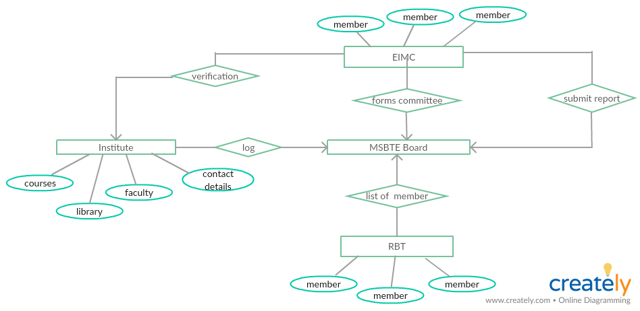

Fig1.System Flow Diagram

- NORMALIZATION:

The basic objective of normalization is to reduce redundancy which means that information is to be stored only once. Storing information several times leads to wastage of storage space and increase in the total size of the data stored.
If a database is not properly designed it can give rise to modification anomalies. Modification anomalies arise when data is added to, changed or deleted from a database table. Similarly, in traditional databases as well as improperly designed relational databases, data redundancy can be a problem. These can be eliminated by normalizing a database.
Normalization is the process of breaking down a table into smaller tables. So that each table deals with a single theme. There are three different kinds of modifications of anomalies and formulated the first, second and third normal forms (3NF) is considered sufficient for most practical purposes. It should be considered only after a thorough analysis and complete understanding of its implications.

Safety & Security Requirements
- Session based security
- Time logs to be maintained in database
- IP based security
- Login details in terms of time, IP provided during each log in

All the data will be periodically copied on remote server. The backed up data on the remote server will be analyzed and compared with the active server on periodic basis. This will ensure reliability and security of the data. The important reports are in PDF format and other reports in HTML format, the security, authentication and validation of the data, data backup, user tracking with session management and user friendliness will give top priority.

Software Quality Attributes
System operation will be carried in high configuration Linux based servers High Bandwidth with Load Balancing concepts. the assurance that the software developed and delivered will be complete in all aspects and should work according to the given specifications.

Other Requirements
Appendix A: Glossary

